EC CHM Project
EUNIS 2 - User guide

Modification history
Date | Version | Author | Reason for modification
12 Nov. 2005 | 0.1 | Daniel Chirca (Finsiel) | First draft
12 Nov. 2005 | 2.0 | Daniel Chirca (Finsiel) | EUNIS 2 Update
Table of Contents
1 Introduction 4
1.1 Purpose of this document 4
1.2 Structure of this document 4
1.3 Field of application 4
1.4 Deviations from PMP 4
1.5 Reference and applicable documents 4
1.6 Terminology 5
1.6.1 Abbreviations, acronyms and definitions 5
1.6.2 Definitions 5
2 Overview 6
3 EUNIS interface 7
4 Easy searches 10
5 Other searches 21
6 Advanced search 28
7 Combined search 31
8 Interactive maps 34
9 DiGIR Provider 36
10 User management 37
11 Accessibility 41
12 Web content management system 43
13 Glossary management 45
14 Related reports 47
15 Feedback 48
16 Login 50
17 Other features of EUNIS 51

Introduction

Purpose of this document
This document describes the functionalities of the EUNIS web application.

Structure of this document
See Table of Contents.

Field of application
Contract | CWU Title | CWU Code
502009.4 | Data flow and data management | WU3

The content of this document will support the usage of the EUNIS web application and related products.

Deviations from PMP
N/a.

Reference and applicable documents

Code | Title | DATE
CHM-DW5-PMP-001 | Project Management Plan | 19 Feb 2003
CHM-DW3-DNC-001 | WU3 Dataflow and data management – Work order | 12 Feb 2003
CHM-DW5-PMP-002 | Production plan | 16 Jan 2003
CHM-DW3-CNT-001 | EUNIS data base with Sites | 03 Mar 2003
CHM-DW3-CNT-003 | EUNIS 2 Database design | 10 Nov 2005
CHM-DW3-CNT-004 | EUNIS Data Base Tool .Net 2.0 – User Guide | 21 Nov 2005

Terminology

Abbreviations, acronyms and definitions
EC | European Commission
EUNIS | European Nature Information System 2
EDTN | EUNIS Database Tool .Net 2.0
ETC/NPB | European Topic Centre / Nature Protection and Biodiversity
EDTN | EUNIS Database Tool NET
CHM | Clearing-House Mechanism
ROD | Reporting Obligations Database
MoE | Ministry of Environment
WU | Contractual Work Unit
EEA | European Environment Agency
EIONET | Environmental Information and Observation Network
IG | Interest Group (in CIRCA)
NFP | National Focal Point
SA1 | 1st Specific Agreement
SA2 | 2nd Specific Agreement
SA3 | 3rd Specific Agreement
SA4 | 4th Specific Agreement
PMP | Project Management Plan
N/a | Not applicable

Definitions
CIRCA or CIRCLE | The extranet tool developed under the IDA Programme and which constitutes the kernel of the EIONET system; CIRCLE is the name given to the tool in EIONET whereas CIRCA is the name of the tool to be used across Europe.
Interest Group | CIRCLE (i.e. CIRCA) is organised around Interest Groups i.e. a private workspace for a group of people that need to collaborate to achieve common objectives and tasks.
Interest Group Leader | In the context of CIRCLE, the Interest Group Leader is granted extended privileges to administrate, manage and customise the Interest Group. S/he defines users and grant access rights within the Interest Group.

Overview
EUNIS – European Nature Information System is a web application available to the general public at http://eunis.eea.eu.int. EUNIS provides information on nature biodiversity. EUNIS 2 is the next version of EUNIS, originally release at the end of 2003 as version1.
EUNIS data are collected and maintained by the European Topic Centre for Biodiversity and Nature Protection for the European Environment Agency and the European Environmental Information Observation Network to be used for environmental reporting and for assistance to the NATURA2000 process (EU Birds and Habitats Directives) and coordinated to the related EMERALD Network of the Bern Convention.
EUNIS contains mainly of information on Species, Habitat types and Sites. Other information regarding Designations, Author references, geographical locations, maps are also available in EUNIS.
The information includes data on Species, Habitats and Sites compiled in the framework of the NATURA2000 (EU Habitats and Birds Directives), but also data collected by ETC/NPB (formerly the European Topic Centre for Nature Conservation) from literature and other sources as reference data.
Specific data was collected in the framework of the EEA reporting activities, which also constitute a core set of data to be up-dated periodically. More information on this subject can be found at the following address: http://biodiversity-chm.eea.eu.int/information/database/.
In order to use EUNIS, an Internet browser is required. The browser should be capable of interpreting Java Script to fully use EUNIS. For this, make sure you have enable Java Script in your Internet browser. If you need to view the PDF files generated by EUNIS, also Adobe Acrobat Reader Free Edition is required. The search results that can be downloaded from EUNIS can be used within Microsoft Excel.
EUNIS does not use cookies, frames, multimedia content, except for the GIS module – developed in Macromedia Flash (it is used as a client for the maps server located in Copenhagen) and the interactive user tutorials, built also in Flash. EUNIS does not collect private information as users surf habits or other data. However, once a user is authenticated, the user can save bookmarks, search criteria and visual interface options. For supplemental information regarding copyright, disclaimer and EUNIS usage, please read the copyright page, which is direct accessible from each page by clicking the ‘Copyright and Disclaimer’ linked at the bottom of the page or by entering the following address in your internet browser: http://eunis.eea.eu.int/copyright.jsp.

EUNIS is a search-based application: the user search for information and the results are displayed or downloaded.

EUNIS interface
The Home page of EUNIS is the index.jsp page (http://eunis.eea.eu.int/index.jsp).
When the users enter the EUNIS web site, the Home page is displayed. The main content of the Home page is shown in the next image:
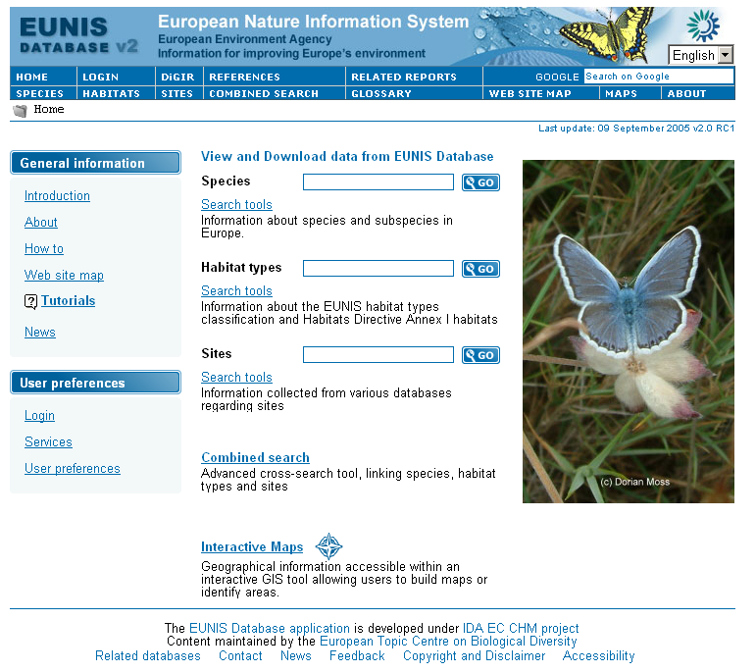

From this page, users can:
- Go to the Species, Habitat types or Sites modules
- Enter search criteria for Species, habitat types and Sites
- Login into EUNIS – ‘Login’
- Go to Combined search – ‘Combined search’
- Go to references used in EUNIS (Authors, books etc.) – ‘References’
- Open the interactive EUNIS map browser – ‘Interactive maps’
- Find more information about EUNIS – ‘About EUNIS data‘, ‘Introduction’ etc.
- Navigate to the site map – ‘Site map’
- Go to interactive tutorials – ‘Tutorials’
- Change the visual theme used in EUNIS pages – ‘Preferences’. By default the blue based colour theme is used through the pages.
- Send feedback, view related EUNIS information etc.
Every EUNIS page contains a menu (the header of the page) for quick site navigation:
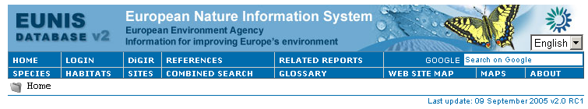
Users can click these links to access different EUNIS functions. Tooltips are available through all the menus and pages. According to the current location, at the bottom of the main menu there is a dynamic menu related to the current location inside the EUNIS structure.
At the bottom of each EUNIS page (the footer of the page), there is a navigation and information bar:

The menu and the footer are common to every page.

Note: There is another way to quickly access the EUNIS functions: The ‘Site map’ page which is accessible from the EUNIS menu. Site map gives direct access to EUNIS functions:

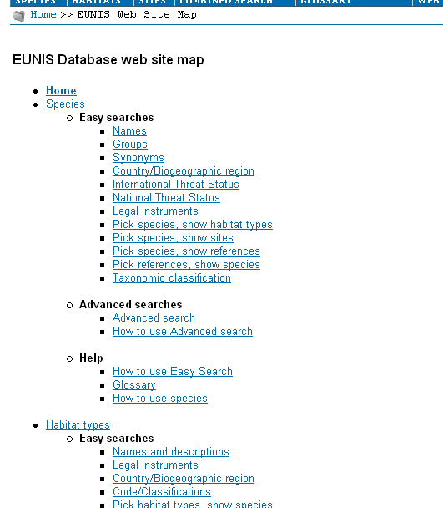

Easy searches
Easy searches built into EUNIS are a set of predefined queries for species, habitat types and sites:
Species easy search page:
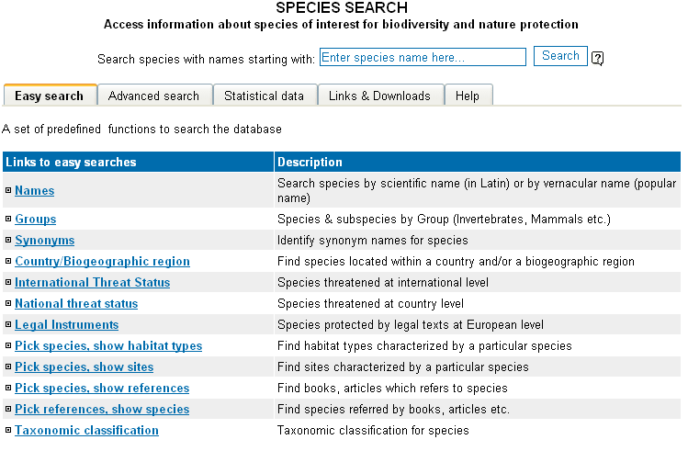

Habitats easy search page:
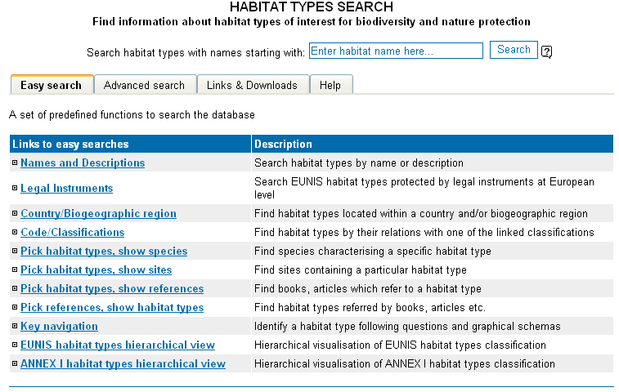

Sites easy search page:
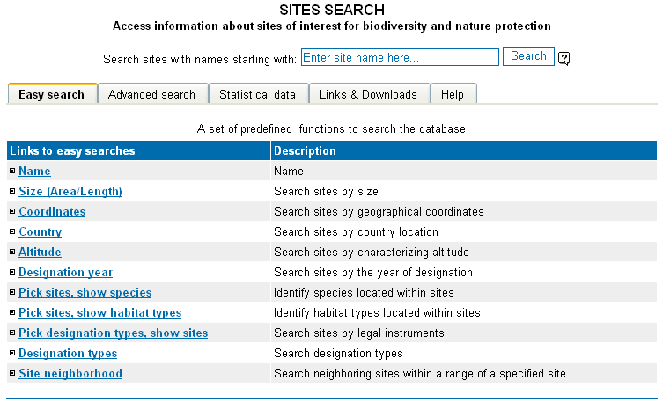

The following easy searches were developed:
Species:
- Name/Vernacular name
- Country/Biogeoregion
- Groups
- Synonyms
- International threat status
- National threat status
- Legal instruments
- Pick species, show habitat types
- Pick species, show sites
- Pick species, show references
- Pick references, show species
- Taxonomic classification

Habitat types:
- Name/Description
- Country/Biogeoregion
- Code/Classifications
- Legal instruments
- Pick habitats, show species
- Pick habitats, show sites
- Pick habitats, show references
- Pick references, show habitats

Sites:
- Name
- Country
- Size
- Coordinates
- Altitude
- Pick sites, show species
- Pick sites, show habitats
- Designation year
- Designation type
- Sites neighbourhood
- Statistical information
These functions are available to all users, from each of the main pages designed for species, habitats and sites. The only difference between an anonymous user and a registered user is in the Species module, where the results provided for an anonymous user do not contain species which are not validated by EUNIS.
In every easy search, user will provide a value(s) for the characteristic field(s) used to filter the database information. In most of the cases, values can be retrieved from list of values, by clicking the binocular image to the right of the field. There is also tooltip help information for every field that can be specified in the search criteria.
To search for all values, you must use the ‘%’ wildcard character.
Note: When the users execute a search by name, in Species, Habitat types or Sites, if no results are found, EUNIS automatically proceed to a “phonetic” search to check if the database contains eventually names which matches the phonetic values of the search string. The algorithm used for this procedure is the well-known SOUNDEX.
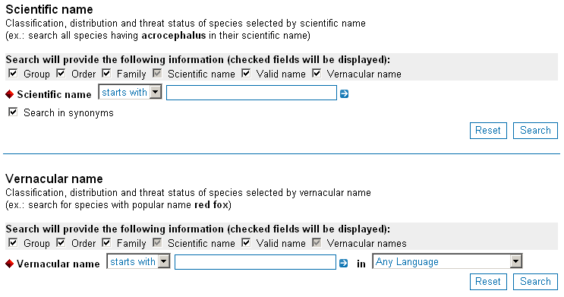
Users can specify which columns of information should be displayed in the results page. Some of the columns (marked in grey) will always be displayed.
If a user is registered, down below the pages there is a ‘Save’ criteria button which saves the search criteria for later use. Criteria can be deleted also when the user is logged on.
After the user press the ‘Search’ button, the database search starts. Depending on the complexity of the query, this might take from a few seconds to some minutes. When the search is complete, the results page is displayed.
The results page contains the following items and information:
- The criteria that has been used
- The number of total rows/records found in the database
- Buttons to navigate through pages (first page, previous, next, last page)
- A form to modify the number of records displayed per page
- A form to search in results (refine the query)
- The current page of records displayed in a grid
- The sites easy searches also contain a button ‘Show map’ which displays a map with the geographical location of the sites found.
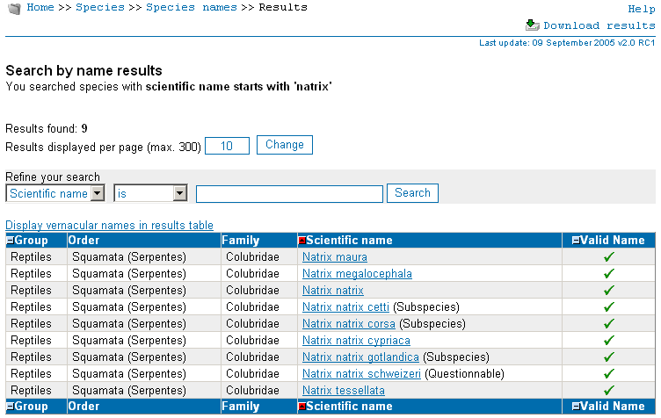

In the results pages, the dynamic menu contains a hyperlink named ‘Download results’. This can be used to download the results of the current search in a tab delimited values file – TSV file. This file can be easy imported in Microsoft Excel. Also, the user can send the results as TSV-separated value by email. The latest version gives also the opportunity to download results in XMLformat.

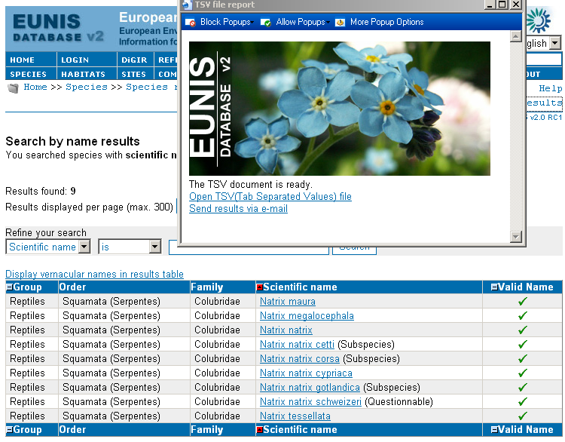

If the user click on the hyperlinks associated with each of the records displayed, the browser will navigate to the factsheet of that record. There are 4 types of factsheets in EUNIS:
- Species
- Habitat types
- Sites
- Designation types

The information in factsheets is organized in tab pages. Clicking on a tab header will load another page of information.
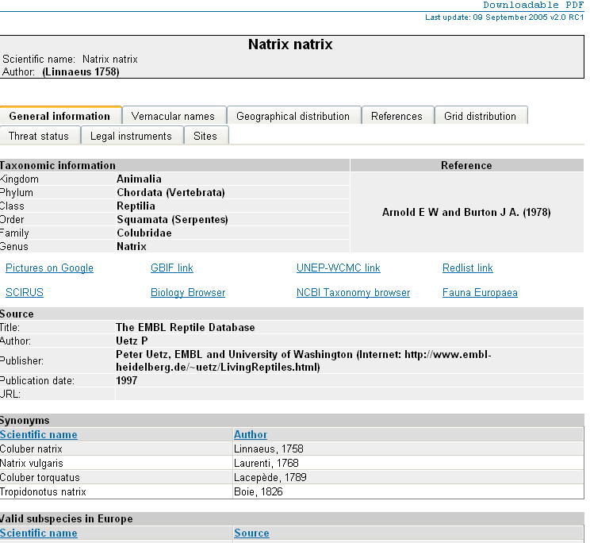
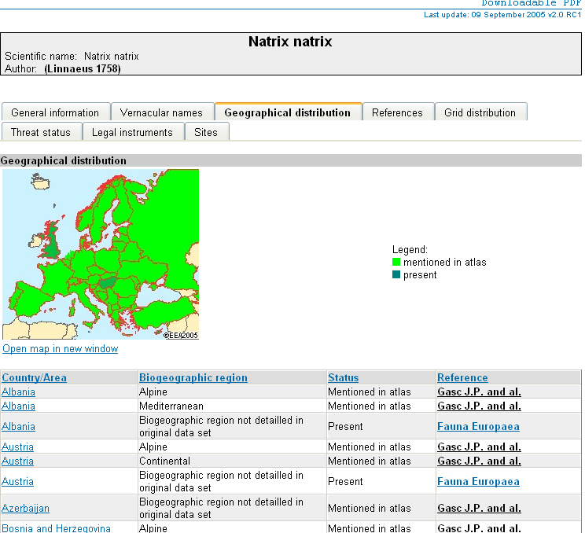

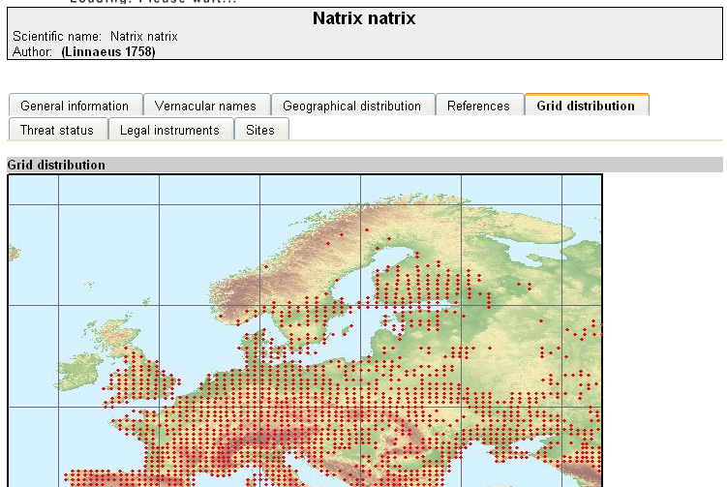

A factsheet is a page containing all the data EUNIS has for that particular nature object. Factsheets are complex pages, containing text, images (maps provided by the EEA map service), links to relate nature objects, diagrams etc. The above images show a n extras from a species factsheet.
The factsheet page can be downloaded as a PDF file generated by EUNIS, if the user clicks the link “Printable PDF” from the menu.

The same applies for habitat types, sites and designation factsheets.

We illustrated above a typical search and get results operation for a species.
Please note that:
- The interactive tutorials accessible from the main menu gives many animated examples of how to performs such operations using EUNIS
- The same mechanism is implemented in all EUNIS searches: user enters a criteria, the results are displayed and the user can get detailed information on an object from the list of results.
- If the user is authenticated (the user does have a username and a password which can be used to perform a login into EUNIS) the search criteria can be saved and retrieved later.

Sometimes, in the tab pages from a factsheet, there are other hyperlinks which display popup windows with details about the current record. For example, ‘geographical implementation’ link from the ‘Legal instruments’ tab:

Other searches
EUNIS provides some special easy searches:
Species:
- Taxonomic browser
Habitat types:
- Key navigation
- Annex I hierarchical view
- EUNIS hierarchical view
Sites:
- Number/Total area
General:
- References

These searches built into EUNIS are different from the other easy searches, being targeted to a specific type of information.
The taxonomic browser displays the taxonomy tree of the species recorded in EUNIS. Clicking on a leaf of the tree will provide a corresponding list of the species.
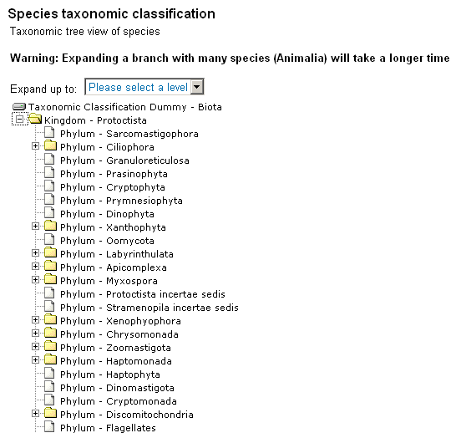

The Key navigation easy search provides an interactive way of identifying a habitat types by a query and answer mechanism. Users can also see diagrams of habitat types classification.

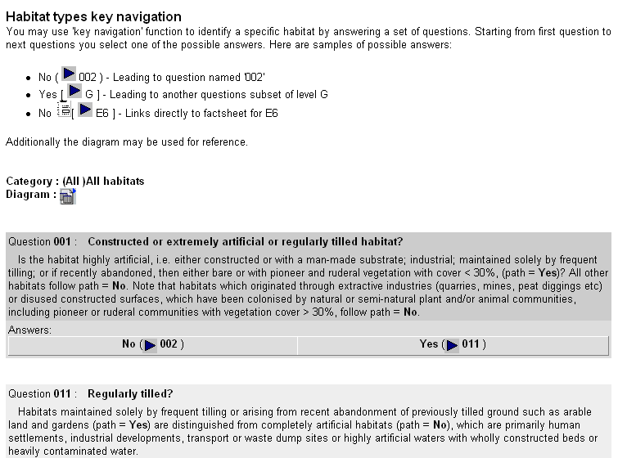

The hierarchical view for habitats (EUNIS or ANNEX I) displays a tree classification of habitat types.
Note: Clicking on a leaf of the tree will provide a small factsheet of the habitat in the page.

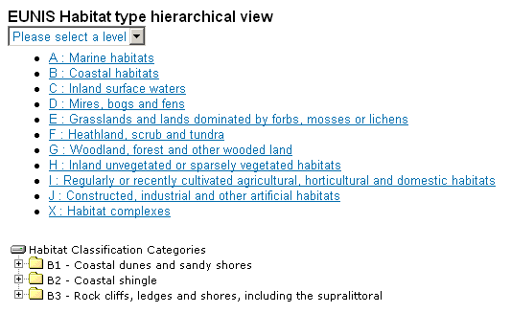

Sites Number/Total area easy search will give the user a page containing statistical data about sites located in a country, grouped by designations.

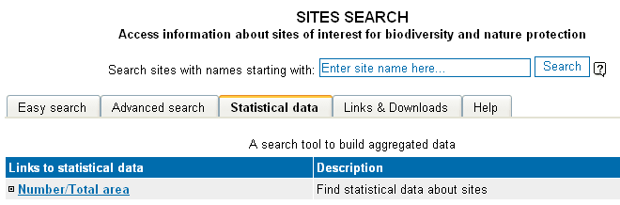
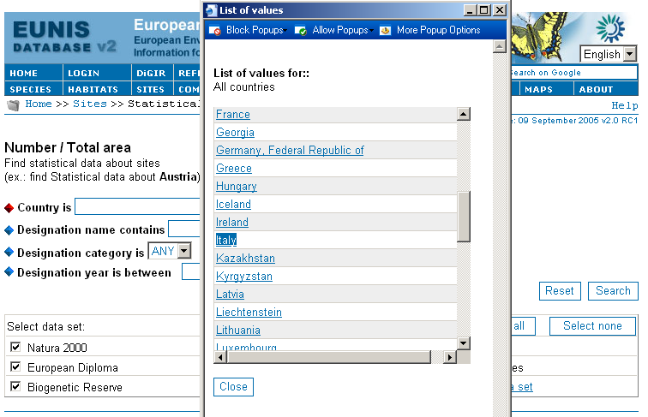

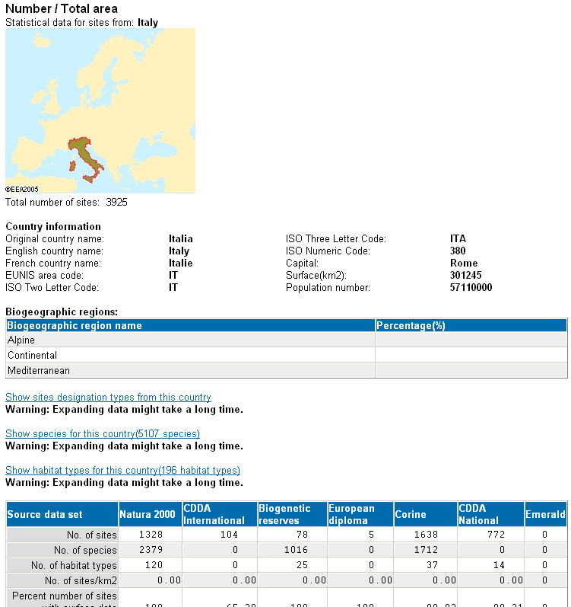

The References search function gives the possibility to search for references used in EUNIS.

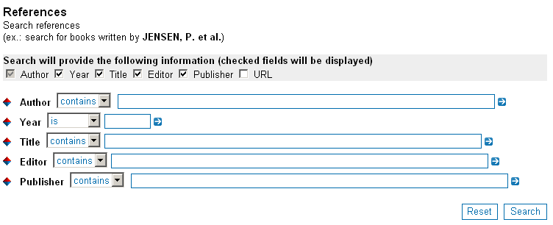

Advanced search
For each type of nature object (species, habitat types and sites) EUNIS provides an advanced search function.
The advanced search function is very flexible by allowing the users to build their own combination of search criteria.
A criteria combination is a set of simple criteria organized as logical expressions, using the operators: All and Any, which corresponds to the AND and OR Boolean operators.
Simple criteria can be grouped together at the same level. The combination criteria are a tree of simple criteria:
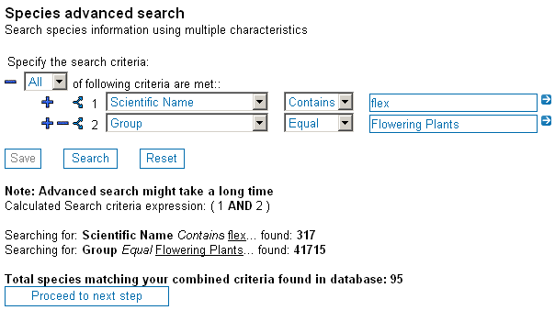

The above image shows a species advanced search criteria. The search of the matching species will be done this way:
- Search all the species having scientific name containing string ‘flex’ and store these values.
- Search all the species belonging to the group ‘flowering plants and store these results.
- Search all the species mentioned in the country ‘Italy’ and store these results.
- Make a UNION of the results found at steps 2 and 3 – the combination operator is ‘Any’, equivalent to OR. Store the results.
- Intersect the results found at steps 1 and 4 – the combination operator is ‘All’, equivalent to AND. Store the results as the final results of this advanced search.
During the search, the number of intermediate results (steps 1, 2 and 3) are displayed as feedback to the user.
If the results found at step 5 are not null, a button will be displayed at the bottom of the page to navigate to the next page.
To the left of each criterion some symbol links are displayed:
- ‘-‘. This is used to remove the criterion, or the whole branch of the tree that starts at the symbol position.
- ‘+’. This is used to add a new criterion at the current level.
- ‘<’. This is used to transform a criterion (a leaf) into a combination of criterion (a node).
There are some limitations imposed to advanced search criteria:
- A maximum number of 9 criterion can be entered at the same level
- There is a maximum depth of the tree set to 3 levels
- The total length of the SQL built internally by the application cannot pass 10 MB.
The next page is the page where the user selects the columns to be displayed in the result page(s). From this page, you can navigate directly to the results page, which is similar to the result page(s) from the easy searches.
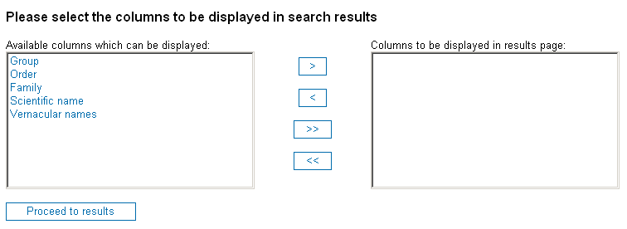

The results page:
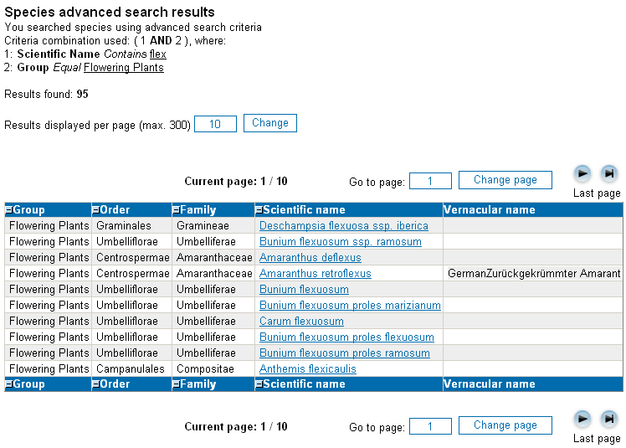

Combined search
The main logical difference between the Combined search and the Advanced search is that combined search queries the database also for relations between different nature objects.
When the users first enters combined search, a panel similar to the one in Advanced Search is displayed. The only difference is a combo-box where user can specify the type of the nature object to search:

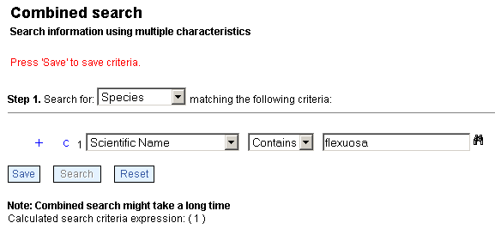

There are three similar pages, where users can specify the selection criteria for each of nature object type used in combination search.
The first and the second page give also the user the opportunity to skip the next object. This means to look only for relations between two types of nature objects, not all three. In this mode combined search behaves as an advanced easy search of type Pick A, Show B, where A and B are types of nature objects (species, habitat types or sites).

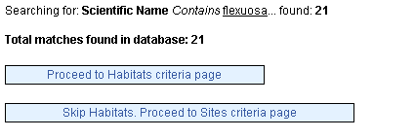

If the user choose to search for a combination of all nature object types, the third page allow users to specify also the combination type which will be performed:

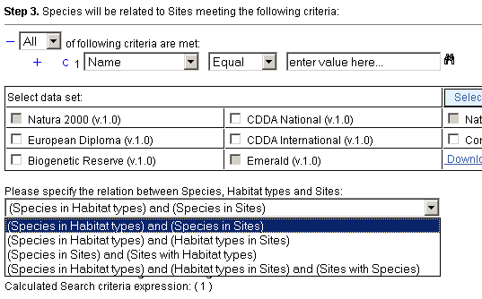

Having three type of data object in the database, the possible links between them are:
- A with B, A with C
- A with B, B with C
- A with C, B with C
- A with B, A with C and B with C,
where A is the nature type object you search for.
The database contains only links between two types of nature objects. Is the application who combines the relations to link A, B and C together.
If the combined search returns some values, next pages are similar to the ones presented in the advanced search.

Combined Search features a supplemental criteria: Regex – Regular Expression,s beside the standard Equal, Contains and Between.

Regular expressions support is built upon the features provided by MySQL for querying data using this type of search.
The following table describes the types of expressions that can be used in EUNIS:

Operator Type | Examples | Description
Literal Characters  Match a character exactly | a A y 6 % @ | Letters, digits and many special  characters match exactly
Literal Characters  Match a character exactly | \$ \^ \+ \\ \? | Precede other special characters  with a \ to cancel their special meaning
Literal Characters  Match a character exactly | \n \t \r | Literal new line, tab, return
Literal Characters  Match a character exactly | \cJ \cG | Control codes
Literal Characters  Match a character exactly | \xa3 | Hex codes for any character
Anchors and assertions | ^ | Field starts with
Anchors and assertions | $ | Field ends with
Anchors and assertions | [[:<:]] | Word starts with
Anchors and assertions | [[:>:]] | Word ends with
Character groups  any 1 character from the group | [aAeEiou] | any character listed from [ to ]
Character groups  any 1 character from the group | [^aAeEiou] | any character except aAeEio or u
Character groups  any 1 character from the group | [a-fA-F0-9] | any hex character (0 to 9 or a to f)
Character groups  any 1 character from the group | . | any character at all
Character groups  any 1 character from the group | [[:space:]] | any space character (space \n \r or \t)
Character groups  any 1 character from the group | [[:alnum:]] | any alphanumeric character (letter or digit)
Counts  apply to previous element | + | 1 or more ("some")
Counts  apply to previous element | * | 0 or more ("perhaps some")
Counts  apply to previous element | ? | 0 or 1 ("perhaps a")
Counts  apply to previous element | {4} | exactly 4
Counts  apply to previous element | {4,} | 4 or more
Counts  apply to previous element | {4,8} | between 4 and 8
Counts  apply to previous element | Add a ? after any count to turn it sparse (match as few as possible) rather than have it default to greedy
Alternation | | | either, or
Grouping | ( ) | group for count and save to variable

Interactive maps
From the home page of EUNIS or from the main menu (‘MAPS’), users can use the Interactive map browser:

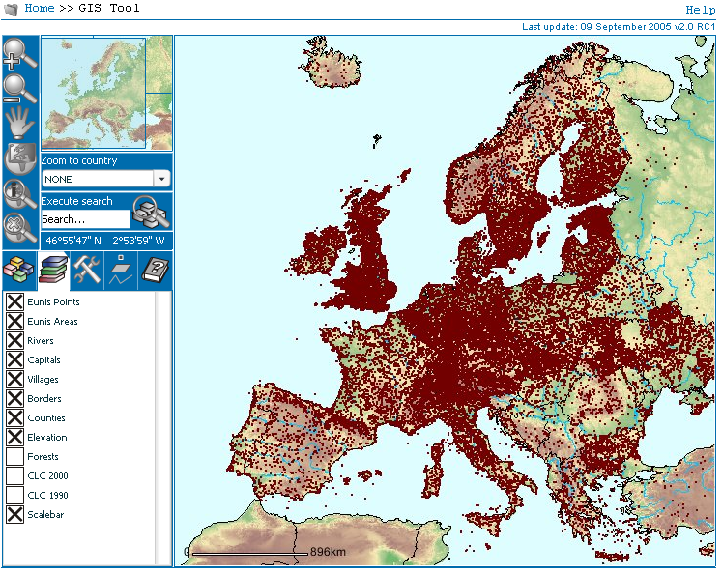

With Interactive map browser, users can:
- Search for a site by name
- Zoom in/out on Europe map
- Retrieve information about a site
- Navigate directly to a corresponding site factsheet
- Enable / Disable labels
- Zoom a specific country
- Display latitude/longitude grid
- Create a printable page with the map image
- Pan through the map
- Have current map position in global reference map
- Choose sites to be displayed grouped by specifying area size through mouse selection

For more information on how to use the GIS Tool, the user should access the interactive GIS tutorials, from the Tutorials page.

DiGIR Provider
EUNIS comes with a DiGIR Provider. The data from the EUNIS database is used to create a table called ‘eunis_digir’. This table is used by a dedicated application (the GBIF DiGIR Provider) to expose species information to the public via GBIF registry.
The data is transmitted in XML format – DIGIR schema. Accessing the ‘DiGIR’ menu from the main menu displays a window containing information about the status of the DiGIR Provider

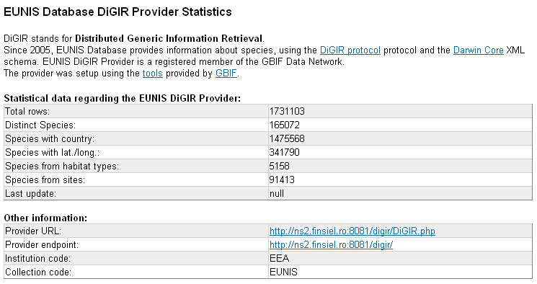

User management
To access this function the user must login, than select the ‘Services’ link from the main page and than the ‘Add, update and delete users and users roles’ function link.
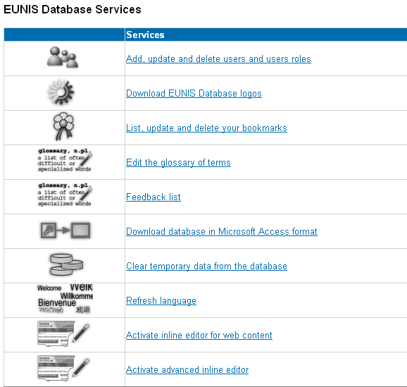

There are three different objects that can be managed using this function:
- Users
- Roles
- Rights
Users are associated with rights through roles. A role is a collection of rights. So first, you need to define roles and than define users, specifying for which user to what role belongs (the rights are predefined in the application).
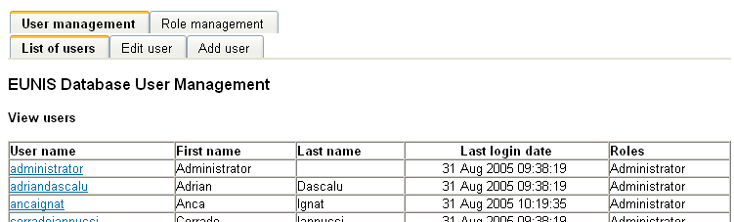
In order to modify a user data, click the username link. The following window will be displayed:
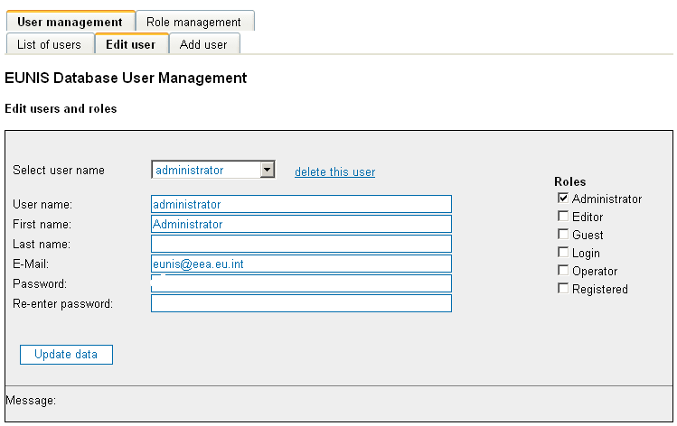

If you need to add a user, you must click ‘Add user’ in the tab page menu:

If you click the ‘Role management’ tab, the roles management panels will be displayed:

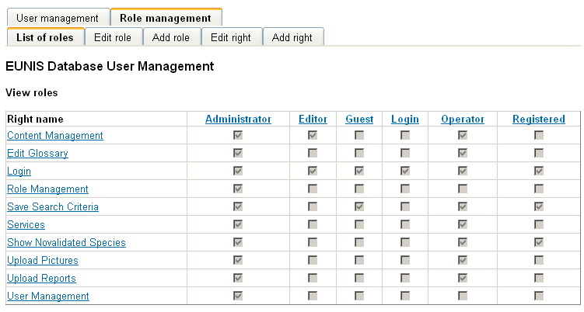
Each role can be updated by clicking on the role name link.

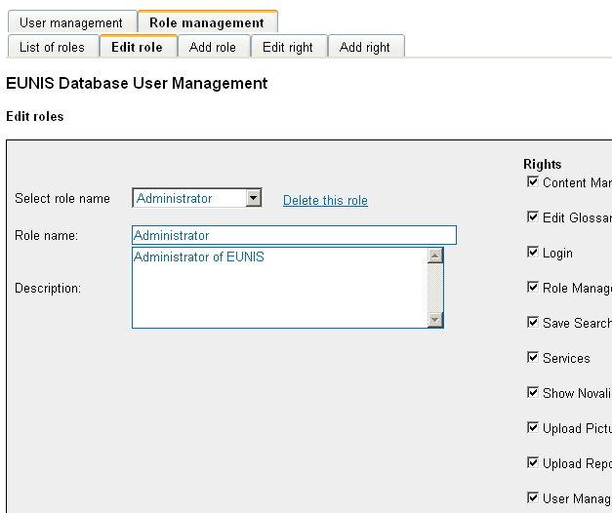

The same considerations apply for updating user rights.

Accessibility
EUNIS 2 was built with accessibility support Level 2.
Accessibility features in EUNIS 2:
Keyboard shortcuts:
Most browsers support jumping to specific links by typing keys defined on the web site. On Windows, you can press ALT + an access key; on Macintosh, you can press Control + an access key (this also depends on the browser used). In EUNIS the following keyboard shortcuts are defined:
- access key 1 - link to home page
- access key 9 - feedback and helpdesk
- access key 0 - link to accessibility statement (this page)
- access key l - link to login
- access key r - link to references
- access key p - link to reports
- access key s - link to Species module
- access key h - link to Habitat types module
- access key t - link to Sites module
- access key 3 - link to site map
- access key g - link to glossary
- access key u - link to GIS Tool
- access key b - link to introduction on EUNIS Database

Standards accessibility compliance:
- the Web Content Accessibility Guidelines 1.0 (WAI-AA)
- pages validate XHTML 1.0 Transitional
- pages validate HTML 4.01
- the Cascading Style Sheets implemented respect the CSS2 Specification
- the web site is still usable without style sheets
- there are still some special pages, like the GIS Tool - implemented in Macromedia Flash and some pages where navigation is based heavily on JavaScript and specific HTML elements where equivalent accessible page content can't be provided and the browsers which don't implement JavaScript will experience reduced functionality. Special measures where taken to announce the user when some functionality is available only on some browsers.
Navigation aids :
- the bread crumb trail - links to all parent folders from the current location to the root
- the navigation for the regular end-users does not imply opening of pop-ups windows (note that some of the administrative pages with more complex functionality do) and the return to the previous page can be easily done through the back button from the browser
- an accessibility link to the main content for every page is provided
Web links accessibility features:
- links have TITLE attributes which describe the link
- links' names make sense out of context
- the links' color is chosen to contrast sufficiently with the background color, and they are distinguishable by having a different text-decoration. Users can choose a personalized theme for the web site.
- visited links and active ones are marked with different colors
Images:
- all content images used in the website include descriptive ALT attributes
- purely decorative graphics include null ALT attributes so they will not be interpreted by speech synthesizers
Visual design features:
- this website uses cascading style sheets (CSS2) for visual layout
- only relative font sizes are used, compatible with the user-specified "text size" option in visual browsers
- the website uses color safely. The pages layout is designed in web safe colors
- if your browser or browsing device used does not support stylesheets at all, the content of each page is still readable and comprehensible
Content structure and other specific elements :
- The HTML code of every page starts with the appropriate DOCTYPE declaration
- The language is identified on every page of the web site
- The heading(s) element of every page - h5 and h6 - have a title specific to he page content:
- Semantically correct markup: the content is well structured and uses the correct HTML tags for the various semantic elements (headers, lists, accessible table information, etc.)
- The web site does not uses frames, multimedia content (video, audio)
- JavaScript is necessary to be enabled in some of the more complex pages
- LABEL elements are used for all visible form elements
- Tables linearize correctly - web site can be used in text based browsers like Lynx
- Metadata information is present in all pages
- TITLE elements are used in every page to provide enhanced user experience and accessibility

Web content management system
This function lets the authorized users to modify the text displayed in EUNIS pages.
The function is accessible from the Services page:
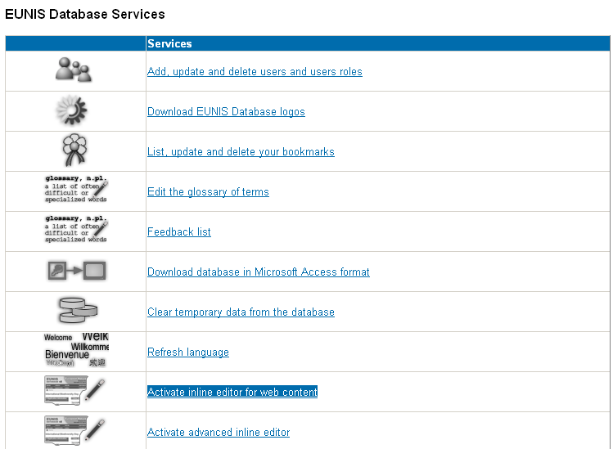

The last two links give access to the online web content management system. The first one, named ‘Activate inline editor for web content’ is used for basic editing – the text displayed on the pages and the second one – called ‘Activate advanced inline editor’ – can be used to edit also the tooltips, the labels used for accessibility purposes, the list values and JavaScript messages.
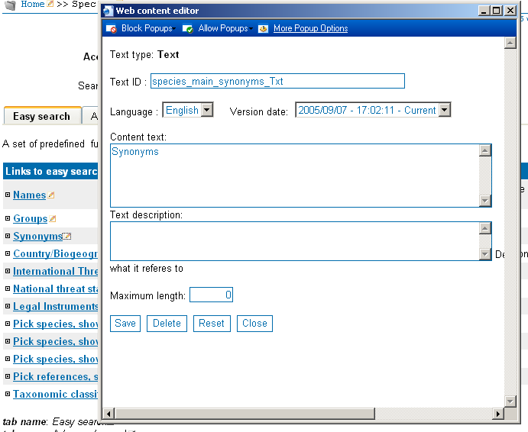
When clicking on the icon displayed next to the text the user wants to edit, the window shown above is displayed.
The user must specify at least the language. The other fields are used for:
- Specifying the new text, if necessary
- Selecting a previous version of the text
- Specifying a description of the text
- Specifying a maximum length for the text – the database will contain only the specified length if the text is longer. 0 means that there are no imposed limits to the text length that will be saved in the database

Glossary management
The glossary management function is available from the Services page, if the user has enough rights.
This function allows users to edit the definition of terms used in EUNIS glossary. Terms can be added, changed or deleted.

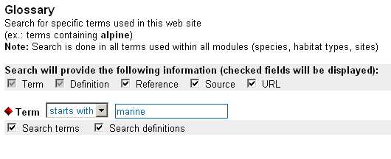
The results of the term search is displayed and the user can Edit the term data.

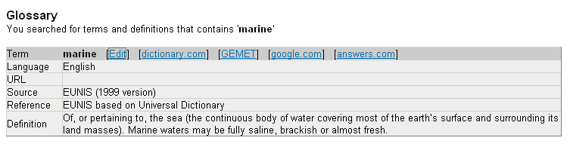

Clicking on a term link gives the window where users can add/ modify term information:

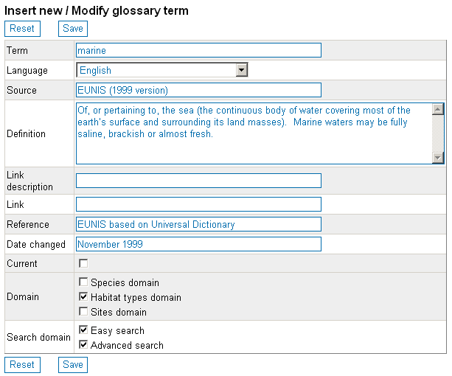

Related reports
EUNIS contains documents related to nature biodiversity which can be freely downloaded by the public. To access this section of EUNIS, a user must be logged on and must click the link ‘Related reports’ from the main menu.

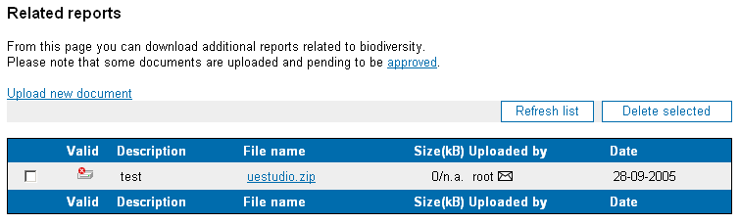

To download a document, you have to right-click on the name of the document and select “Save target as…” from the popup menu (or similar function in other browsers).

Feedback
At the bottom of every EUNIS page there is the footer content area:



If the user clicks the ‘Feedback link in this footer, the feedback page of EUNIS will be displayed:

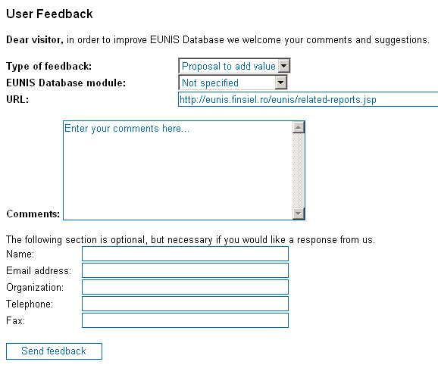

The feedback function can be used to send user comments, notes, suggestion to the EUNIS team. If the user wants to receive a response, he/she should specify at least a valid email address.
The feedback will be send when the button ‘Send feedback’ is clicked. A confirmation page will be displayed.

Login
Some of the features built into EUNIS are available only to the registered users. A user can login:
- From the Home page, clicking the ‘Login’ link.
- From the menu, clicking the ‘Login’ link.
In the popup window, the user must enter the username and the password:

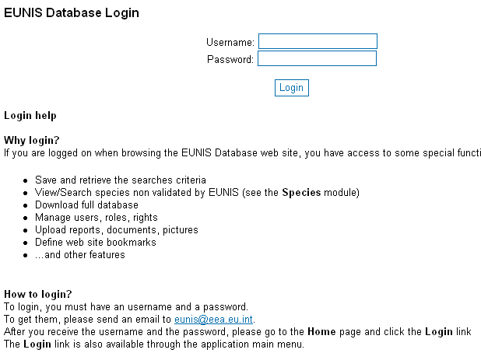

The application will query the user rights from the database and according to the user rights, some of the EUNIS pages will contain additional information or links.
If the user tries to access directly a page, but is not logged or do not have enough rights, a message will be displayed in the browser:

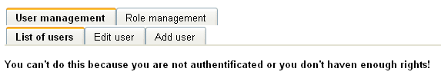

Other features of EUNIS
EUNIS provides some special other features to the authenticated users.
A. Save search criteria.
On each standard easy search page, EUNIS gives the user the possibility to save the search criteria for later use. To access this feature, user must click the ‘Save’ button or link in the page.

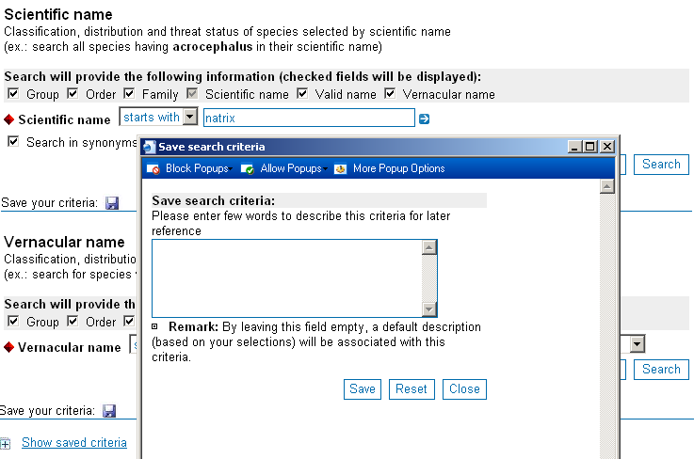

The saved criteria can be restored / deleted later:

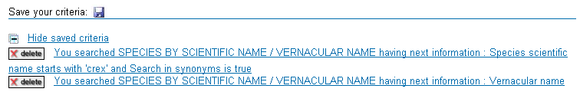

B. Administration special functions.
If the user has Administrator roles, the Services page what is displayed it will look like in the above image:
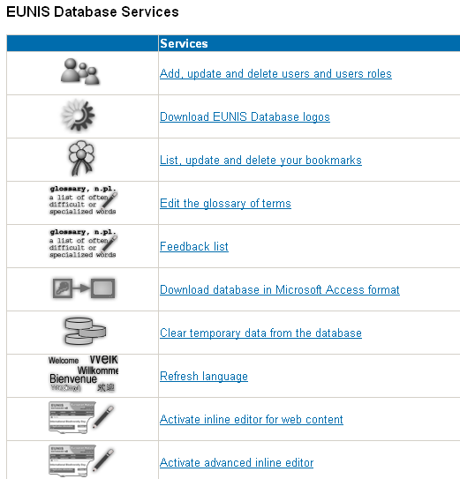
If the user clicks the image associated to the ‘Clear temporary data from database’, a page will be displayed that allow user to clear the temporary data from the database. Temporary data is created whenever an advanced or combined search is done. Normally, the application clears itself this data when the user session expires, but in some circumstances it is necessary to clean the data manually, using this function of EUNIS.

C. Multilanguage support
EUNIS 2 has support for Multilanguage. All pages are encoded in UTF8. The language can be selected/changed from all pages through a simple list selection box displayed in the main menu.

